The Virginia Train Collectors Association’s Spring Toy and Train Show will be held Friday, May 15th and Saturday, May 16th at the Stony Point Fashion Park in Richmond, Virginia. This is a new venue for the VTCA. The show space is a former clothing store (H&M) with approximately 20,000 square feet of floor space.


Stony Point is the same location as the home to VTCA’s Train Depot. The Train Depot is a 4800 square foot store front with 10 train layouts of multiple scale. We have had over 4000 visitors in the first 3 months of operations.
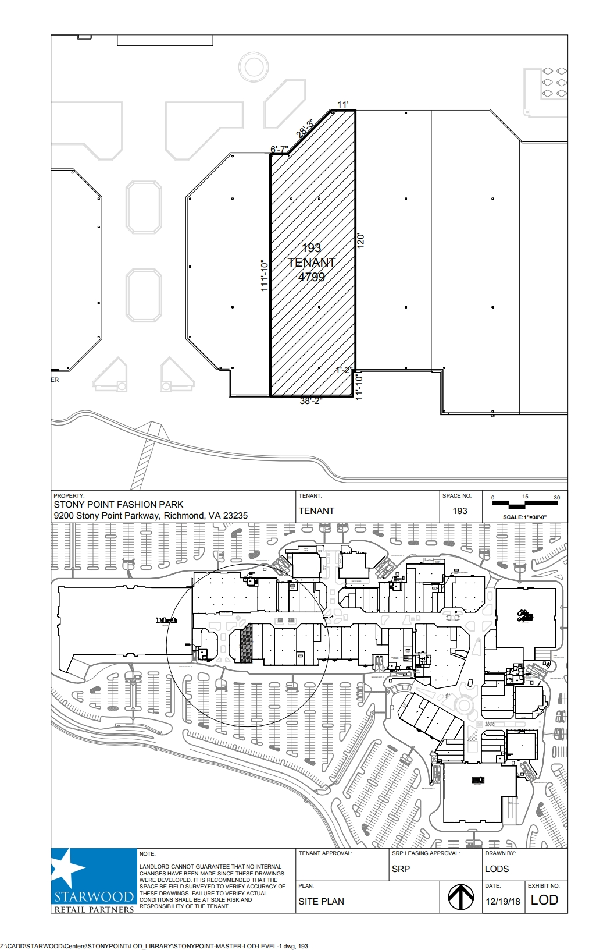

The public show hours will be 12:00 pm to 6 pm on Friday and 9 am to 4 pm on Saturday. We will be promoting this show in conjunction with the mall management and will be using multiple social media channels to generate public interest and traffic.
Vendor set up can begin on Thursday from 1 pm to 6 pm and again on Friday morning from 7 am to 12 pm. There is street level rear access to the store from the parking lot to load and unload your goods for the show.
The price per table is $45 for non-VTCA members or $40 for VTCA members and a $5 registration fee. Tables will be available for set up on Thursday
If you have any questions or need to discuss anything, please contact us at shows@vatraincollectors.com with your name, phone number and item(s) to be discussed. We will respond within 24 hours to all incoming emails. Your show coordinators are Russell Youens and Dave Garlock.
For those not familiar with Stony Point, here are the directions:
Stony Point Fashion Park is located just south of the James River and the Willey Bridge off of Chippenham Park. Access Chippenham from Parham Road on the north, the Powhite Parkway or I-95 on the South.

If you are coming from Parham Road to Chippenham Parkway, take the first right exit off Chippenham after crossing the Willey Bridge marked Stony Point Fashion Park. Bear right and follow the road past the apartments on the right around the curve. You will see the Dillards store up on the hill on the left. Continue to the second left-hand exit across from the Creek’s Edge apartments and park near the entrance to Talbots. The showroom entrance is down the Service alley. A sign will be set up to mark the entrance for vendors.

If you are coming north on Chippenham Parkway from the Powhite (10 minutes from Stony Point exit) or I-95 (30 minutes from Stony Point exit), you will pass the Huguenot Road Overpass and proceed to the Stony Point right-hand exit. Take exit to the light at the bottom of the hill then bear right at the light. Stay in the left lane and go straight through the next two lights and proceed straight. Go about 1/4 of a mile then take the third right-hand exit and park near the Talbot’s. The showroom entrance is down the Service alley. A sign will be set up to mark the entrance for vendors.



